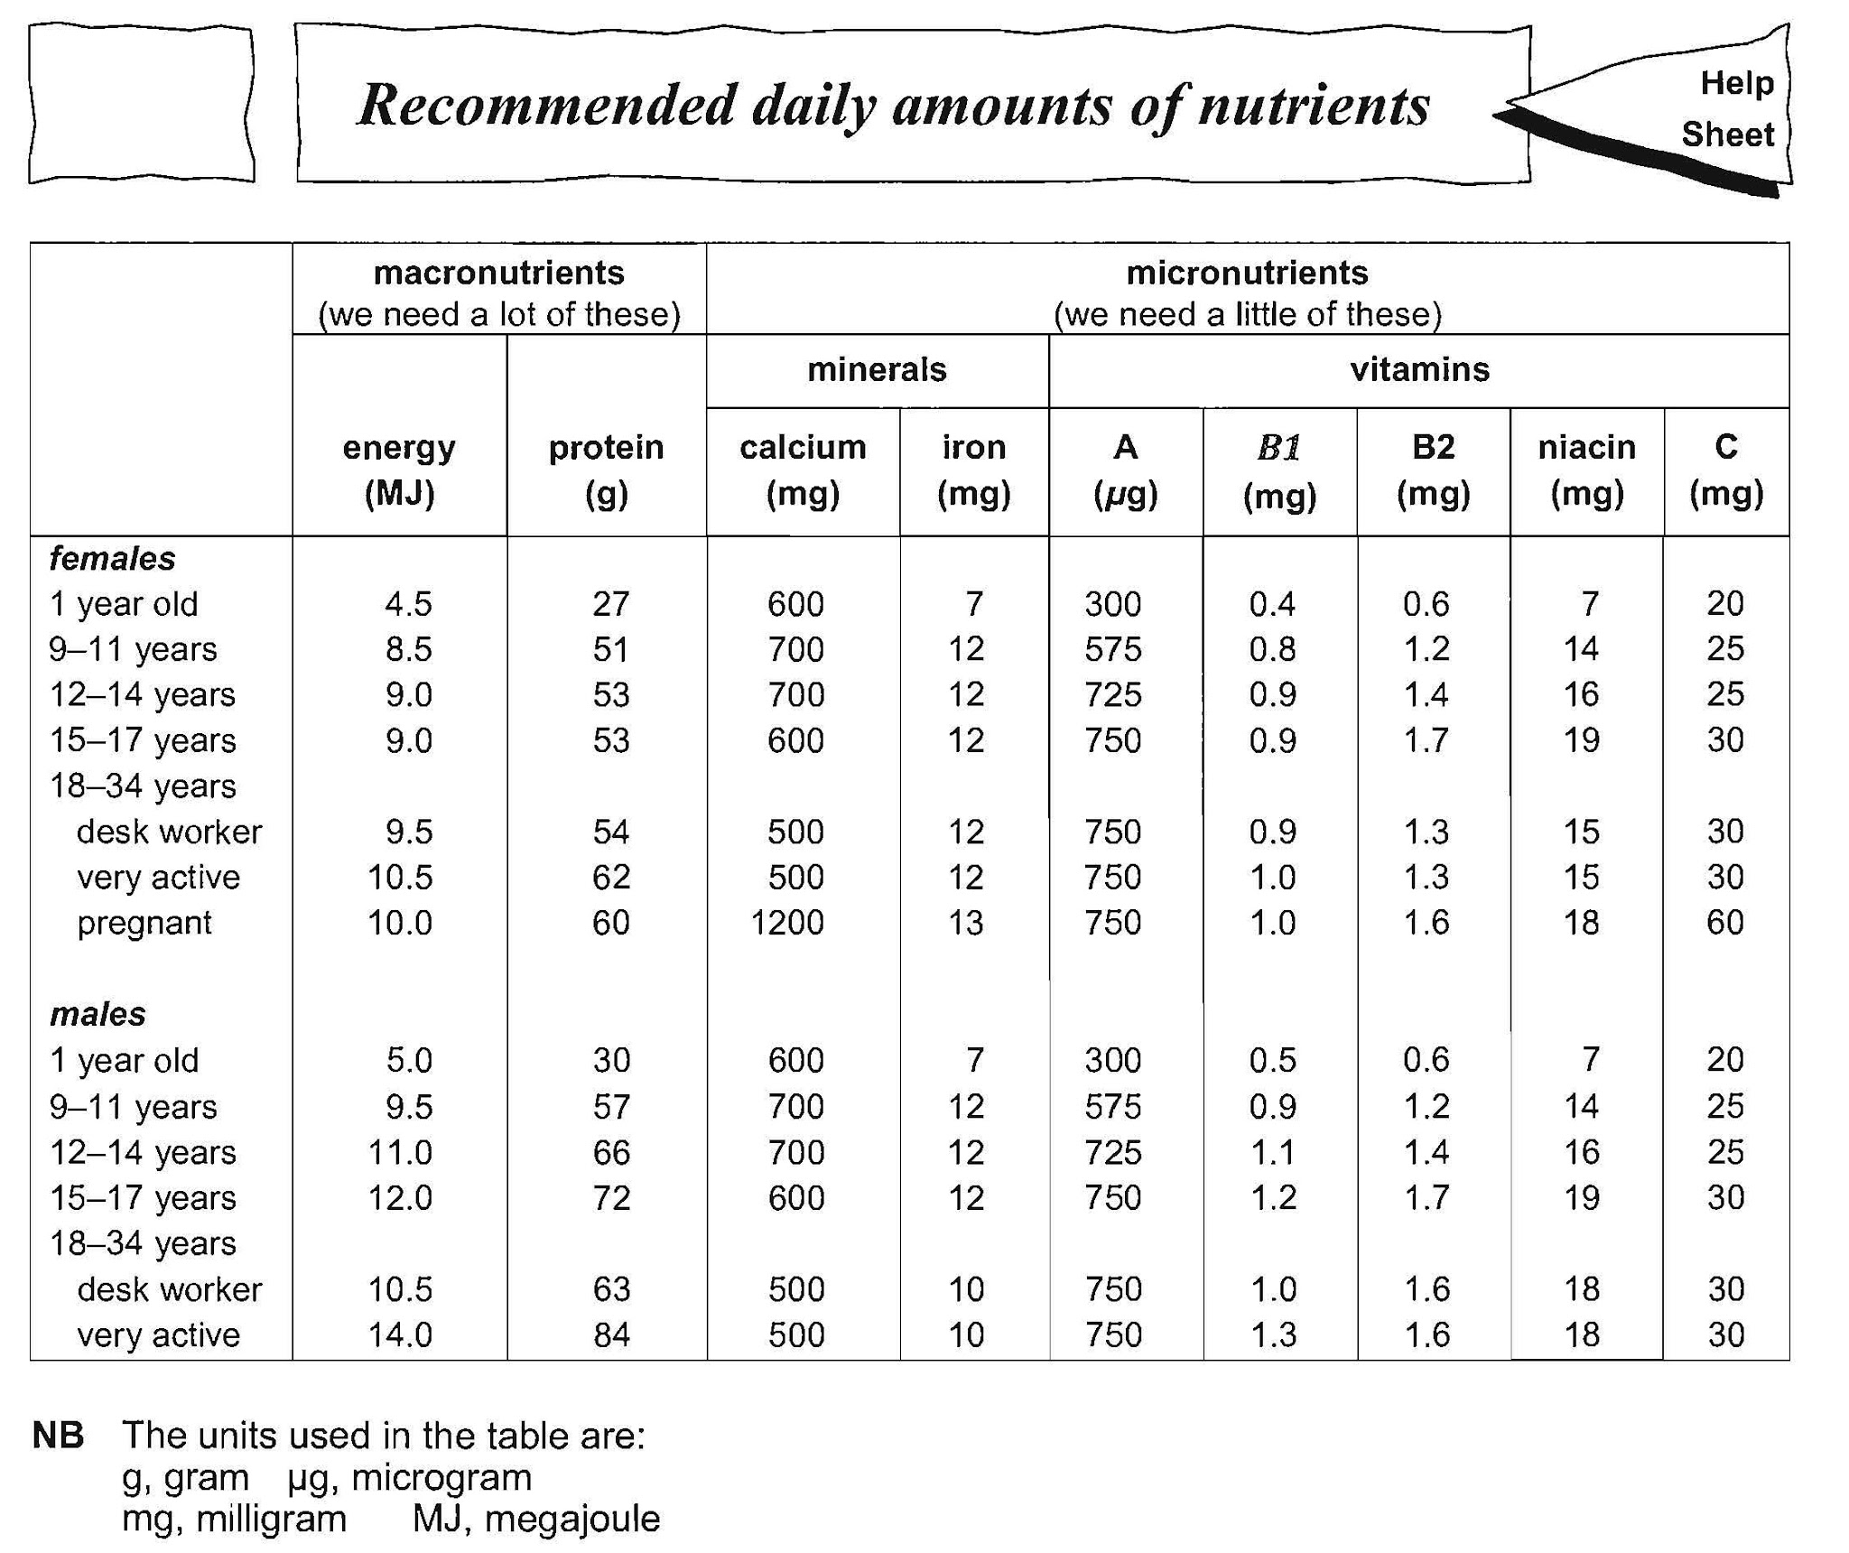

A healthy diet means that you are getting enough of the right nutrients- not too much and not too little. The table above shows “Recommended Daily Amounts” (RDAs” of some of the essential food substances.

- Look up your energy requirements in the table. How do they compare with
- Someone of the same age but of the opposite sex?

- A female worker?

- A very active male worker?

2. Why do you think the energy needed of males increases between the ages of 9 and 17 years?

3. Which two groups show the greatest increase in protein requirement? Why do you think that is?

4. Which group needs most calcium and most iron? Why do you think that is?

